

Student Name:………………………………………

SPECIALIST MATHEMATICS

TRIAL EXAMINATION 2

2015

Reading Time: 15 minutes
Writing time: 2 hours

Instructions to students
This exam consists of Section 1 and Section 2.
Section 1 consists of 22 multiple-choice questions and should be answered on the detachable answer sheet on page 26 of this exam. This section of the paper is worth 22 marks.
Section 2 consists of 5 extended-answer questions, all of which should be answered in the spaces provided. Section 2 begins on page 10 of this exam. This section of the paper is worth 58 marks.
There is a total of 80 marks available.
Where more than one mark is allocated to a question, appropriate working must be shown.
An exact answer is required to a question unless otherwise stated.
Unless otherwise stated, diagrams in this exam are not drawn to scale.
The acceleration due to gravity should be taken to have magnitude 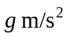where 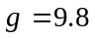.
Students may bring one bound reference into the exam.
Students may bring into the exam one approved CAS calculator or CAS software and, if desired, one scientific calculator. Calculator memory does not need to be cleared.
Formula sheets can be found on pages 23-25 of this exam.

This paper has been prepared independently of the Victorian Curriculum and Assessment Authority to provide additional exam preparation for students. Although references have been reproduced with permission of the Victorian Curriculum and Assessment Authority, the publication is in no way connected with or endorsed by the Victorian Curriculum and Assessment Authority.

© THE HEFFERNAN GROUP 2015
This Trial Exam is licensed on a non transferable basis to the purchasing school. It may be copied by the school which has purchased it. This license does not permit distribution or copying of this Trial Exam by any other party.
SECTION 1

Question 1

The axes intercepts of the ellipse with equation 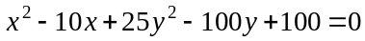 are located at

- 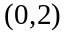 only
- 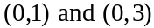 only
- 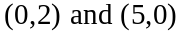 only
- 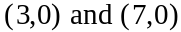 only
- 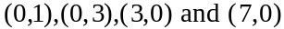 only

Question 2
For the graph of the function with rule 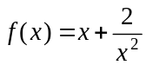, it is not true to say that

- all of its asymptotes pass through the origin
- 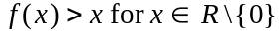
- there is one straight and one curved asymptote
- 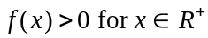
- there is one point of discontinuity

Question 3
The curve defined by 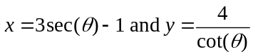 can be written in Cartesian form as

- 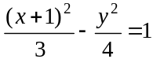
- 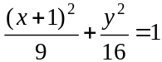
- 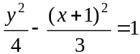
- 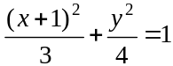
- 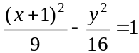

Question 4

The function f has the rule 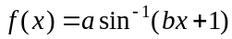, the domain 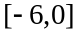 and the range 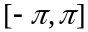. Therefore,

- 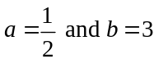
- 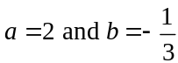
- 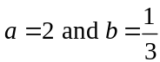
Question 5

If the complex number z has modulus 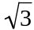 and lies on the imaginary axis of an Argand diagram then z could be equal to

- – 3i
- 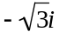
- 3i
- 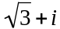
- 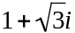

Question 6

Let 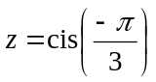.
The imaginary part of 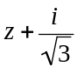 is

- 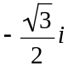
- 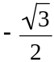
- 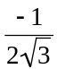
- 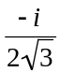
- 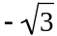

Question 7

Given the two complex numbers 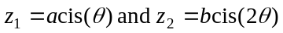, the argument of 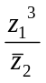 is

- 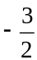
- 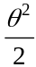
Question 8

The solutions to the equation 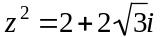 have principal arguments of

- 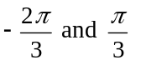
- 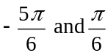
- 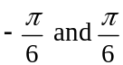
- 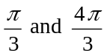
- 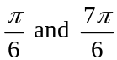

Question 9

The circle with equation 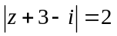 intersects twice with the line that has the equation

- 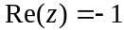
- 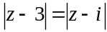
- 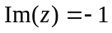
- 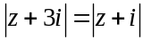
- 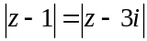

Question 10

A cylindrical tank is filled with liquid to a depth of h metres so that the volume of liquid 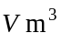 in the tank is given by 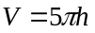. Liquid flows into the tank at the rate of 0.1m³ per hour and leaks out at the rate of 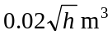 per hour.

A differential equation that relates the variables h and t is

- 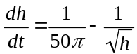

- 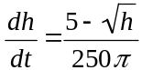

- 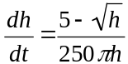

- 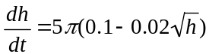

- 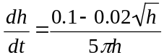
Question 11
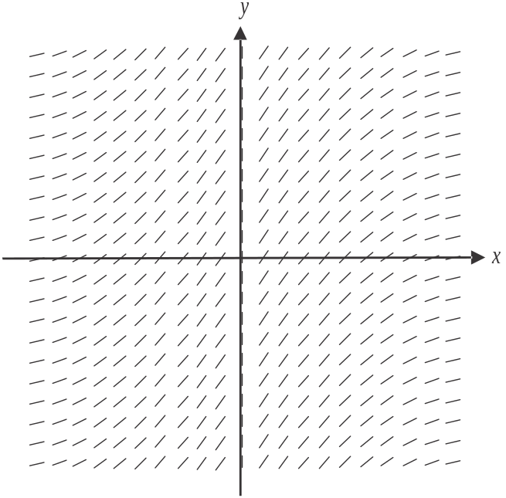

The differential equation that could represent the direction field shown above is

- 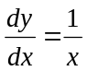
- 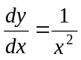
- 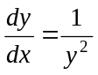
- 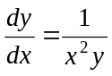
- 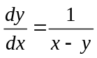

Question 12

For the differential equation 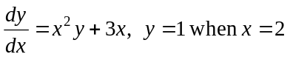. If Euler’s method is used with a step size of 0.1, then the approximation for y when is

- 2
- 3.312
- 3.512
- 3.4
- 4
Question 13

Using a suitable substitution, 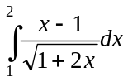 can be expressed as

- 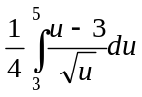
- 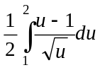
- 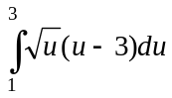
- 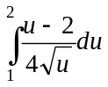
- 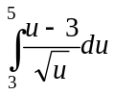

Question 14

A particle is acted on by a force of 8 newtons acting in a direction due west and a force of 10 newtons acting in a direction S30°E.
The magnitude, in newtons, of the resultant force acting on the particle is

- 6
- 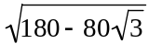
- 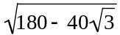
- 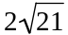
- 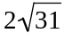

Question 15

The position vector of a particle is given by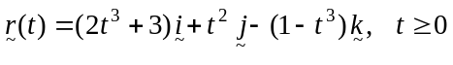.
The magnitude of the acceleration of the particle in m/s² at is

- 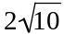
- 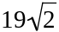
- 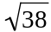
- 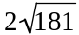
- 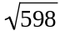
Question 16

Given that the angle between the vectors 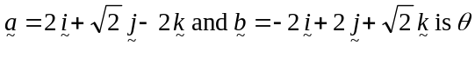, then 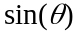 is
- 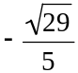
- 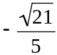
- 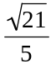

Question 17

The velocity vector of a particle that starts its journey at the origin, is given by

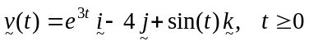.

The position vector of the particle is given by

- 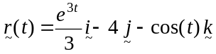
- 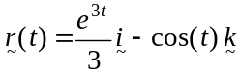
- 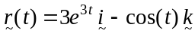
- 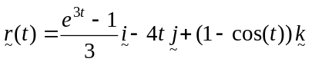
- 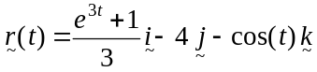
Question 18

An object of mass 3kg is connected to two light inextensible strings which hold it in equilibrium. One of the strings is horizontal and is attached to a wall.
The other string is at an angle of 30° to the vertical and is attached to the ceiling.
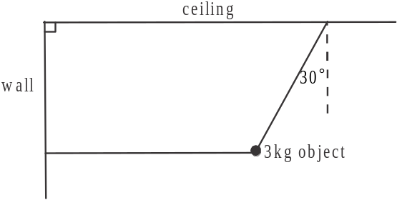

The tension in the horizontal string, in newtons, is
- 3
- 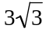
- 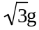
- 3g

Question 19

A light inextensible string passes over a smooth pulley.
Two particles of mass m kg and 3m kg are attached to the ends of the string.
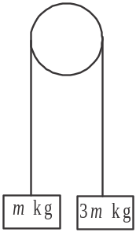

The system is released from rest.
The speed of the 3m kg particle will be 24.5m/s after

- 1.25 seconds
- 2 seconds
- 2.5 seconds
- 3 seconds
- 5 seconds

Question 20

A particle of mass 4kg is moving in a straight line with a velocity of 6m/s when it is acted on by a force of 9 newtons acting in the opposite direction to the motion of the particle.
The particle will come to rest after travelling a further distance of

- 8m
- 16m
- 20m
- 24.5m
- 40.5m
Question 21

The velocity-time graph is shown below for a particle travelling in a straight line with velocity v m/s at time t seconds.
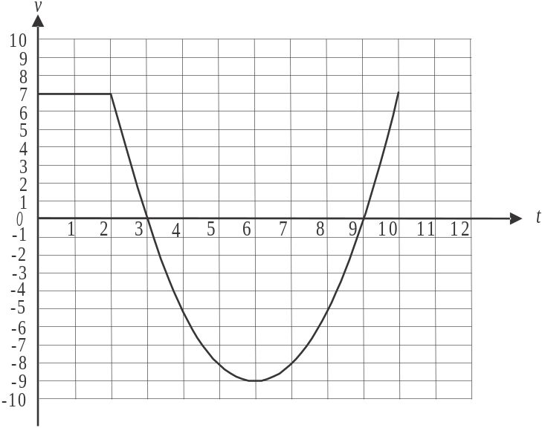

For 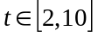 the velocity of the particle is given by 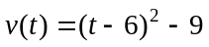.
The distance travelled, in metres, by the particle for 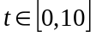is
- 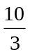
- 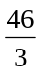
- 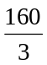
- 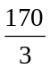
- 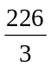

Question 22

A particle moves in a straight line with an acceleration, in m/s², given by 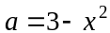 where x is its displacement, in metres, from a fixed origin at O.
If the particle is at rest at O, then the particle will also be at rest where

A. 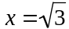 only
B. only
C. only
D. 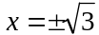 only
E. only

SECTION 2

Question 1 (11 marks)

A curve is defined by the parametric equations 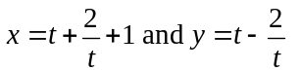 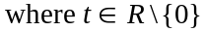.

- Show that the Cartesian equation of the curve is 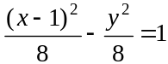. 2 marks

- Find the values of t when the gradient of the curve is 2. 3 marks

- Sketch the graph of , showing clearly the asymptotes and any axes intercepts. 3 marks

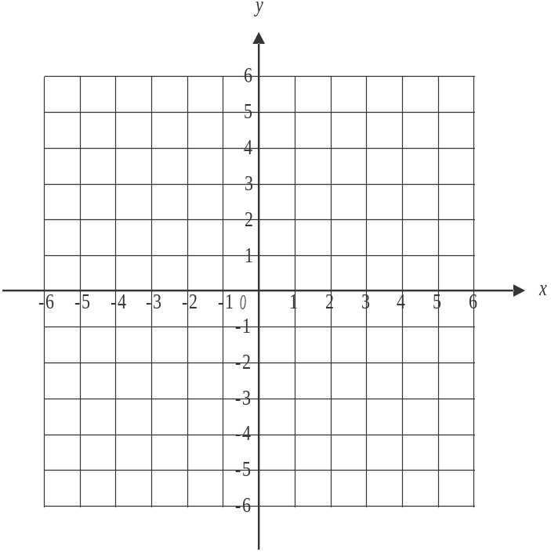

The region enclosed by the graph of and the line is rotated about the x-axis to form a solid of revolution.

- Find the volume of this solid of revolution. 3 marks

Question 2 (13 marks)

Let 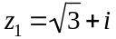 .

- Express in polar form. 2 marks

- Verify that is one root of the equation 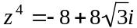. 1 mark

- If 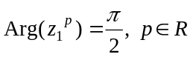, find all the possible values of p. 2 marks

Line L lies in the complex plane and has the equation 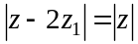.

- i. Show that the Cartesian equation of L is given by 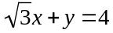. 2 marks

- Show that 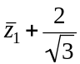 satisfies the relation . 2 marks

- i. Sketch L and the graph of 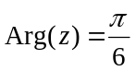 on the argand diagram below. 2 marks
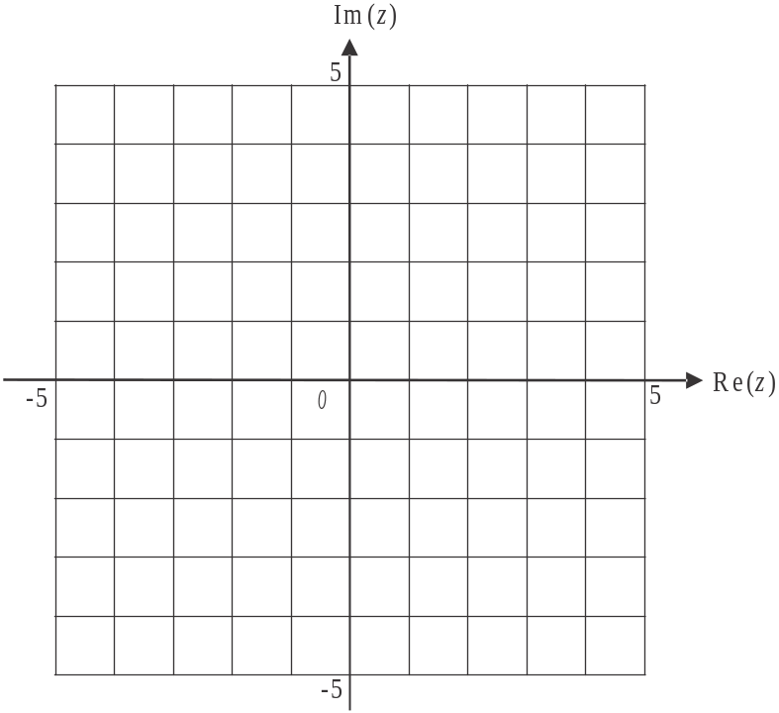

- The area in the first quadrant enclosed by the y-axis and the graphs of L and , is equal to the area enclosed by the graphs of L, 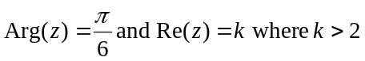. Find the value of k. 2 marks

Question 3 (12 marks)

The position vectors of two drones R and S, relative to a tower at O, are given respectively by

.

The unit vectors 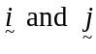 are directed to the east and north of O respectively.
The displacement components are measured in kilometres and time, t, is measured in hours.

- Show that the Cartesian equation of the path of drone S is 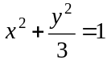. 2 marks

The path followed by drone R is shown on the set of axes below.

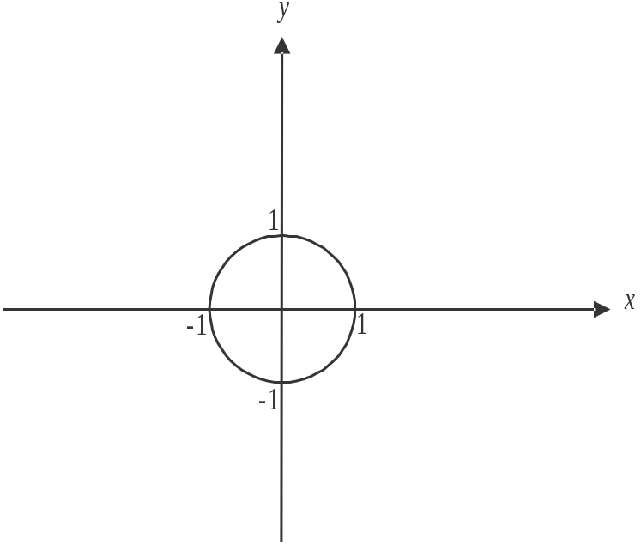

- Sketch the path followed by drone S on the set of axes above. 2 marks

- Find the starting position of each of the drones, expressing them in Cartesian coordinates. 2 marks

- Show that the drones never meet. 2 marks

- Find the speed of drone R, in km/hr, at . 1 mark

- Find the magnitude of the acceleration of drone R, in 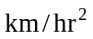, at 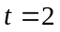. 1 mark

  - Show that at 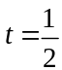, the drones are travelling in directions that are perpendicular to each other. 2 marks

Question 4 (10 marks)

In a high rise development, the number of apartments, N, that are sold t days after a marketing campaign begins is modelled by the equation 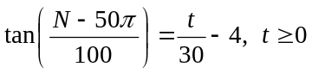.

- Find the number of apartments that are pre-sold, that is, sold before the marketing campaign begins. Express your answer to the nearest integer. 1 mark

- According to this model, what is the limiting number of apartments that can be sold. Express your answer to the nearest integer. 1 mark

- Using implicit differentiation to find 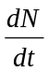, verify that 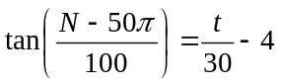 satisfies the differential equation 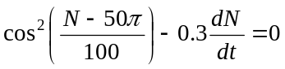. 2 marks

The graph of the function 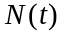 has a point of inflection at the point 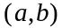.
Also, an alternative form of the differential equation given in part c., is

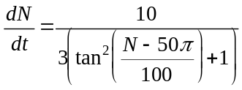.

- Using this alternative form of the differential equation or otherwise, find 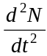 and hence find the values of a and b. 4 marks

- Sketch the graph of the function on the set of axes below for 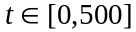. 2 marks

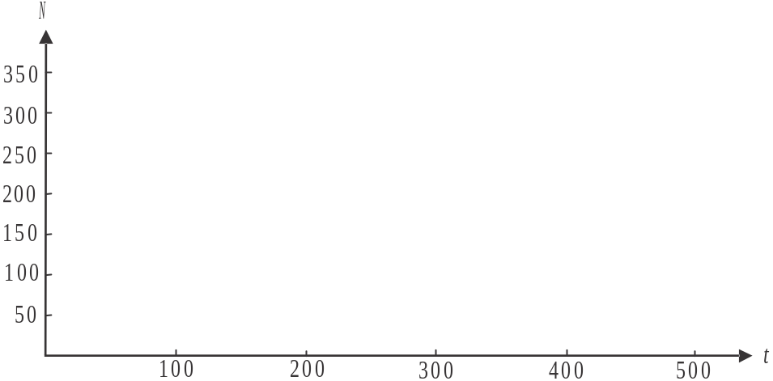

Question 5 (12 marks)

A mass of 7kg is on a smooth plane inclined at degrees to the horizontal where 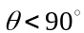. It is connected by a light inextensible rope which passes over a smooth pulley, to a mass of 3kg which is hanging vertically, as shown in the diagram below.

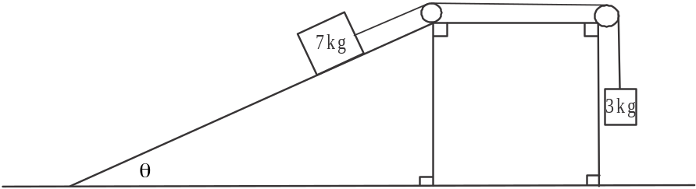

- i. Write down an equation of motion for the mass of 7kg when it is moving down the plane. 1 mark

- Write down an equation of motion for the mass of 3kg when it is moving vertically upwards. 1 mark

- Show that 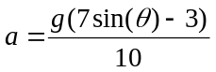. 1 mark

- If the system is to be in equilibrium, find the value of expressed in degrees correct to one decimal place. 1 mark

- If the 3kg mass is to be moving vertically upwards, find the possible values of expressed in degrees correct to one decimal place. 1 mark

The smooth inclined plane is replaced with a rough plane that is inclined at an angle of 30° to the horizontal as shown in the diagram below.

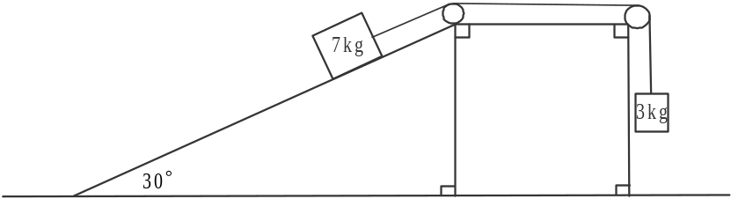

The coefficient of friction between the rough plane and the 7kg mass is 0.106.
The 3kg mass and the 7kg mass are at rest.

- Show that the 7kg mass is not on the point of moving down the plane. 2 marks

The rope breaks.

- Find the acceleration of the

                - 7kg mass down the slope giving your answer in m/s², correct to the nearest 0.01m/s². 2 marks

                - 3kg mass vertically downwards. 1 mark

The distance that the 7kg mass has to travel down the inclined plane to reach the horizontal surface is three times the distance that the 3kg mas has to travel vertically to reach the horizontal surface.

- Using your answers to part c., find the ratio of the speed of the 3kg mass to the speed of the 7kg mass as they each reach the horizontal surface after the rope breaks. 2 marks

Specialist Mathematics Formulas

Mensuration
area of a trapezium: 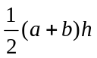
curved surface area of a cylinder: 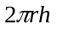
volume of a cylinder: 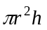
volume of a cone: 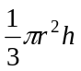
volume of a pyramid: 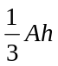
volume of a sphere: 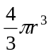
area of a triangle: 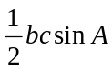
sine rule: 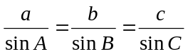
cosine rule: 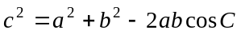

Coordinate geometry
ellipse: 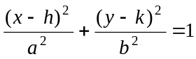 hyperbola: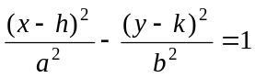

Circular (trigonometric) functions
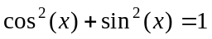
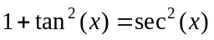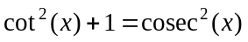
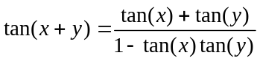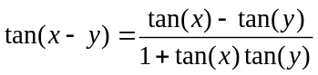
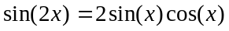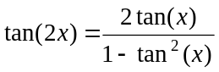
function | 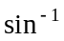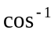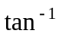
domain  range | 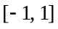  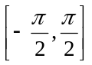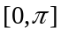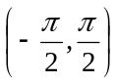

Algebra (Complex numbers)
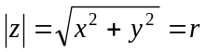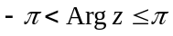
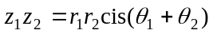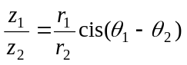
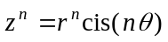 (de Moivre’s theorem)
Mathematics Formula Sheets reproduced by permission; © VCAA 2014. The VCAA does not endorse or make any warranties regarding this study resource. Current and past VCAA VCE® exams and related content can be accessed directly at www.vcaa.vic.edu.au
Calculus

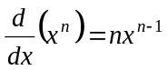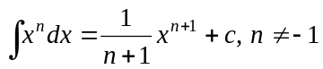
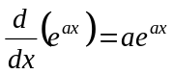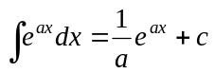
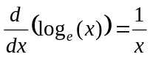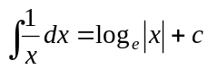
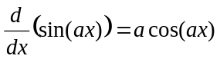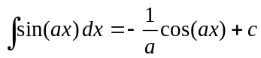
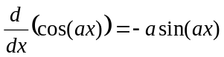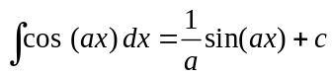
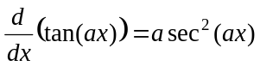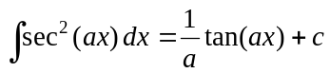
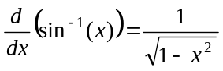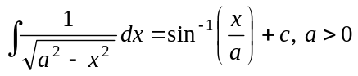
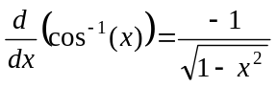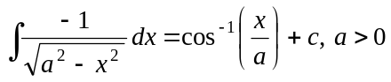
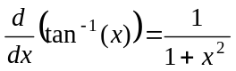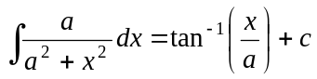

product rule: 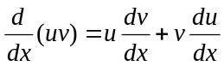
quotient rule: 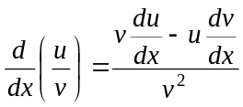
chain rule: 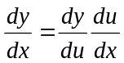
Euler’s method: 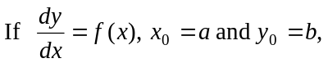
acceleration: 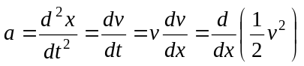
constant (uniform) acceleration: 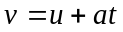 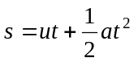 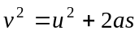 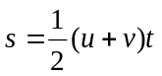

Vectors in two and three dimensions

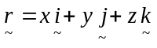
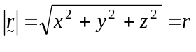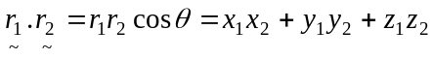
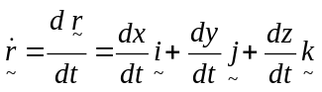

Mechanics

momentum: 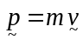
equation of motion: 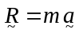
friction: 